Assignment 4:

**Creation of Jar.**

* Created a SpringBoot project Hello -> <https://github.com/lokesh16191/hello.git>
* Project contains all project related files.
* If we perform mvn clean install, it will create a jar inside target folder.

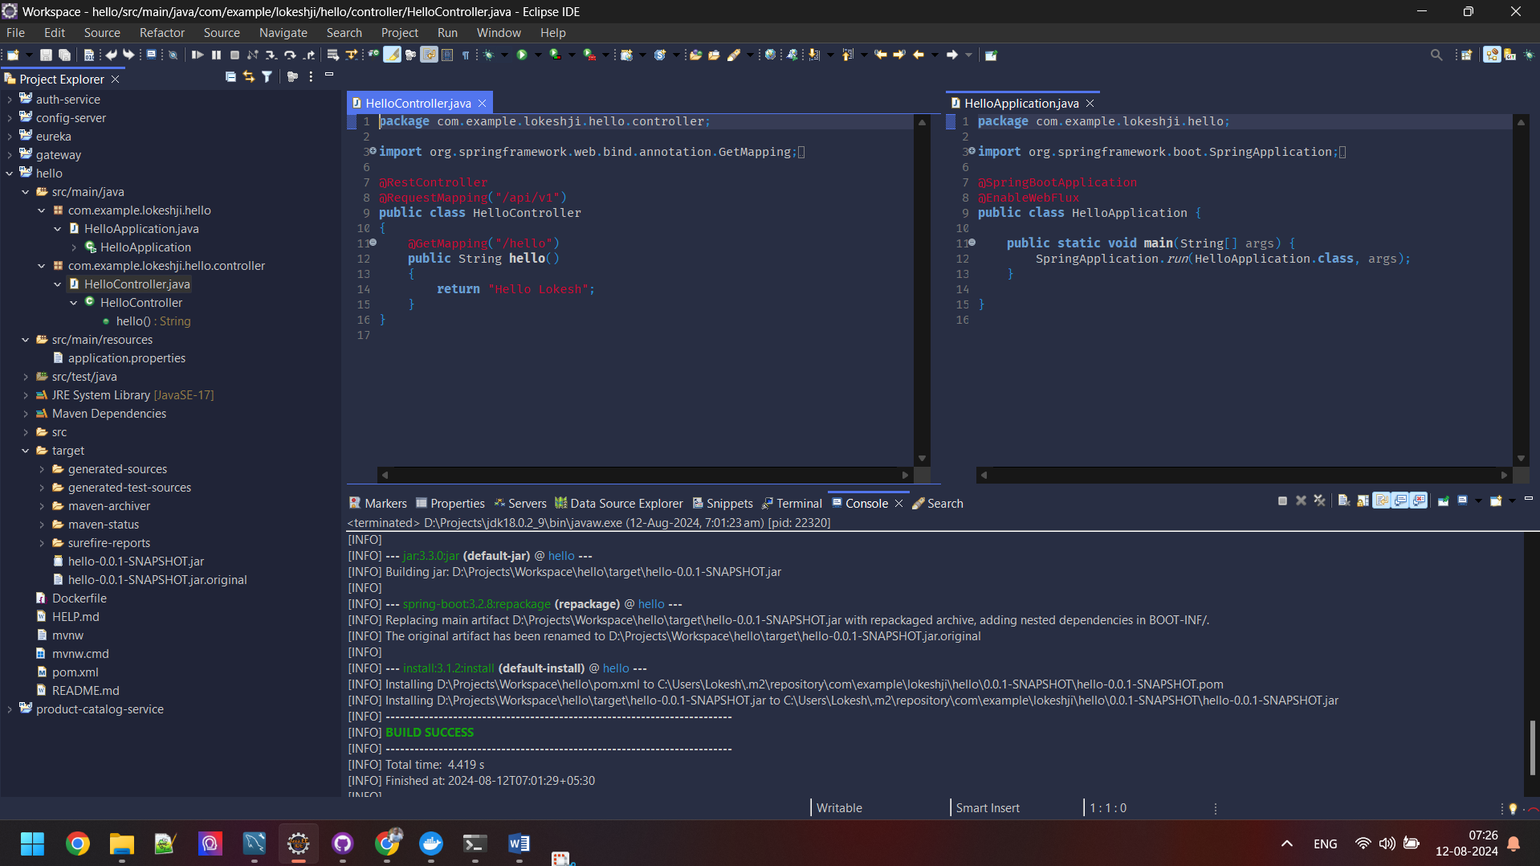

**Build the Docker Image:**

Used docker init command on project directory and given responses to interactive UI options:

* 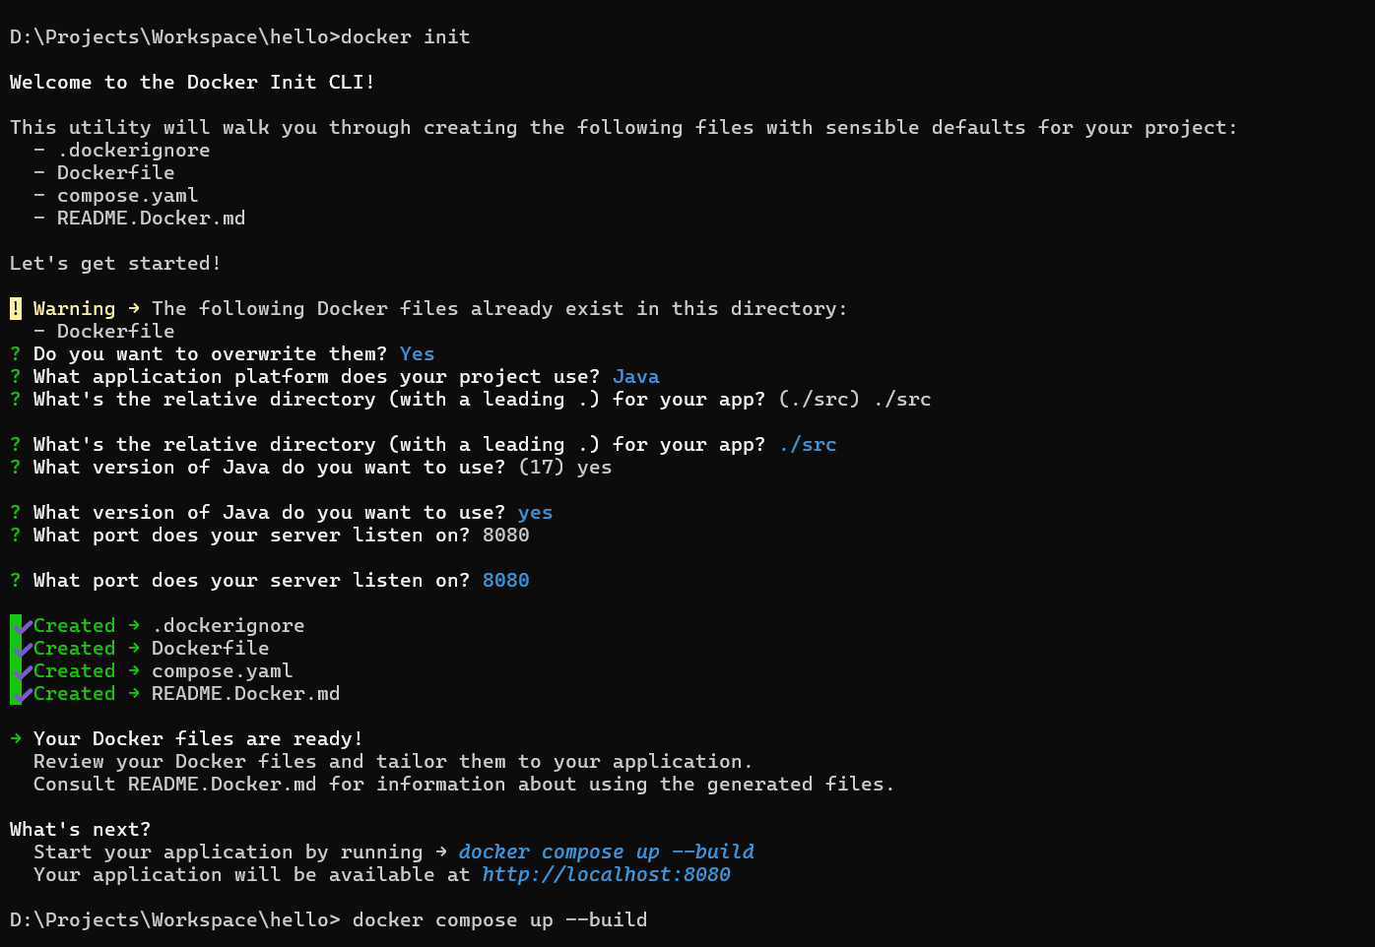

**Launch Docker Container**

Perform compose up –build command and it has launched the container and created image.

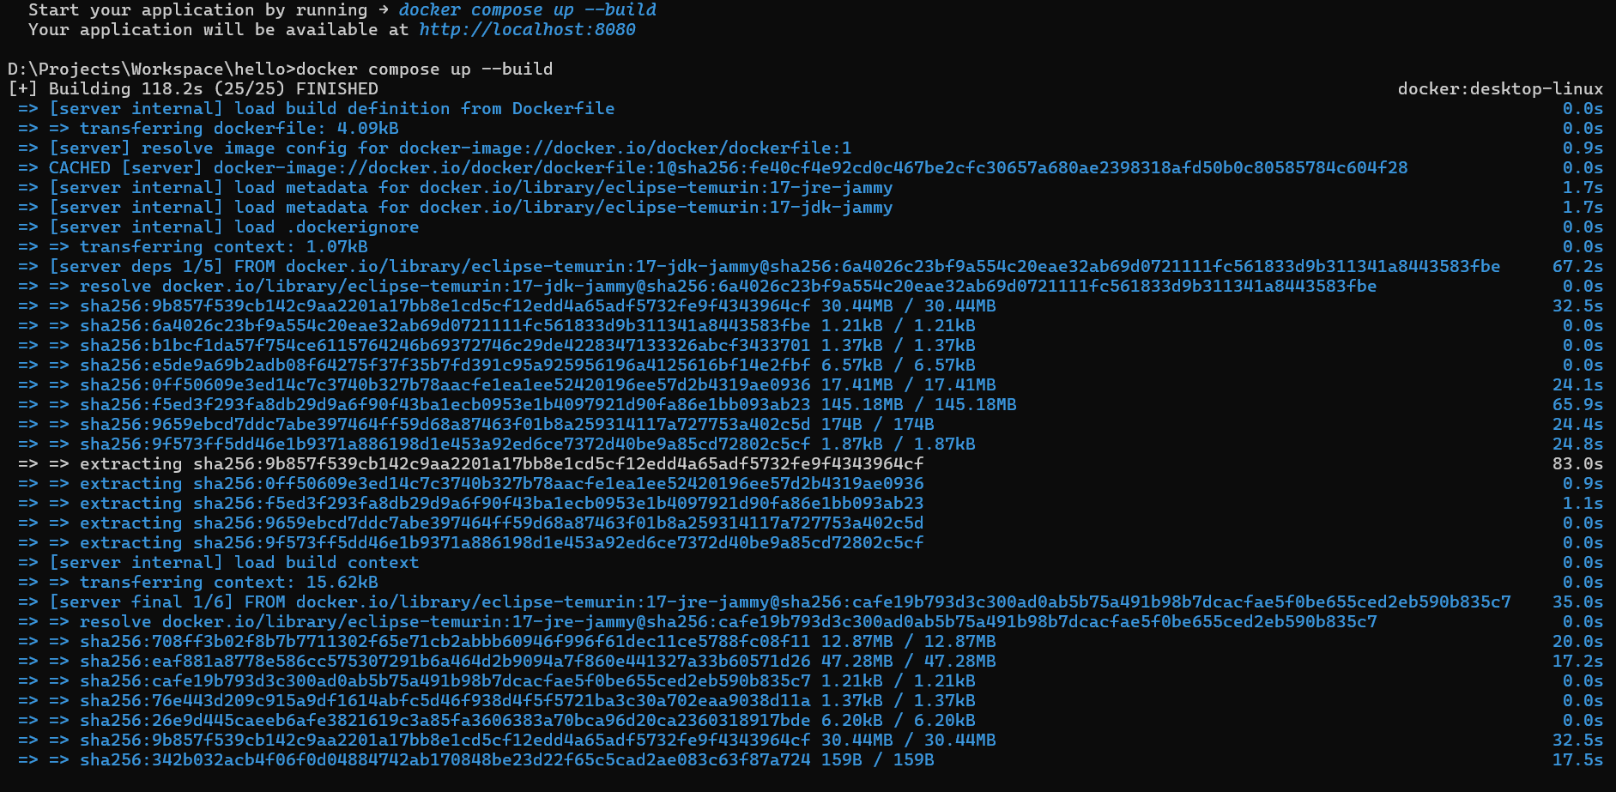

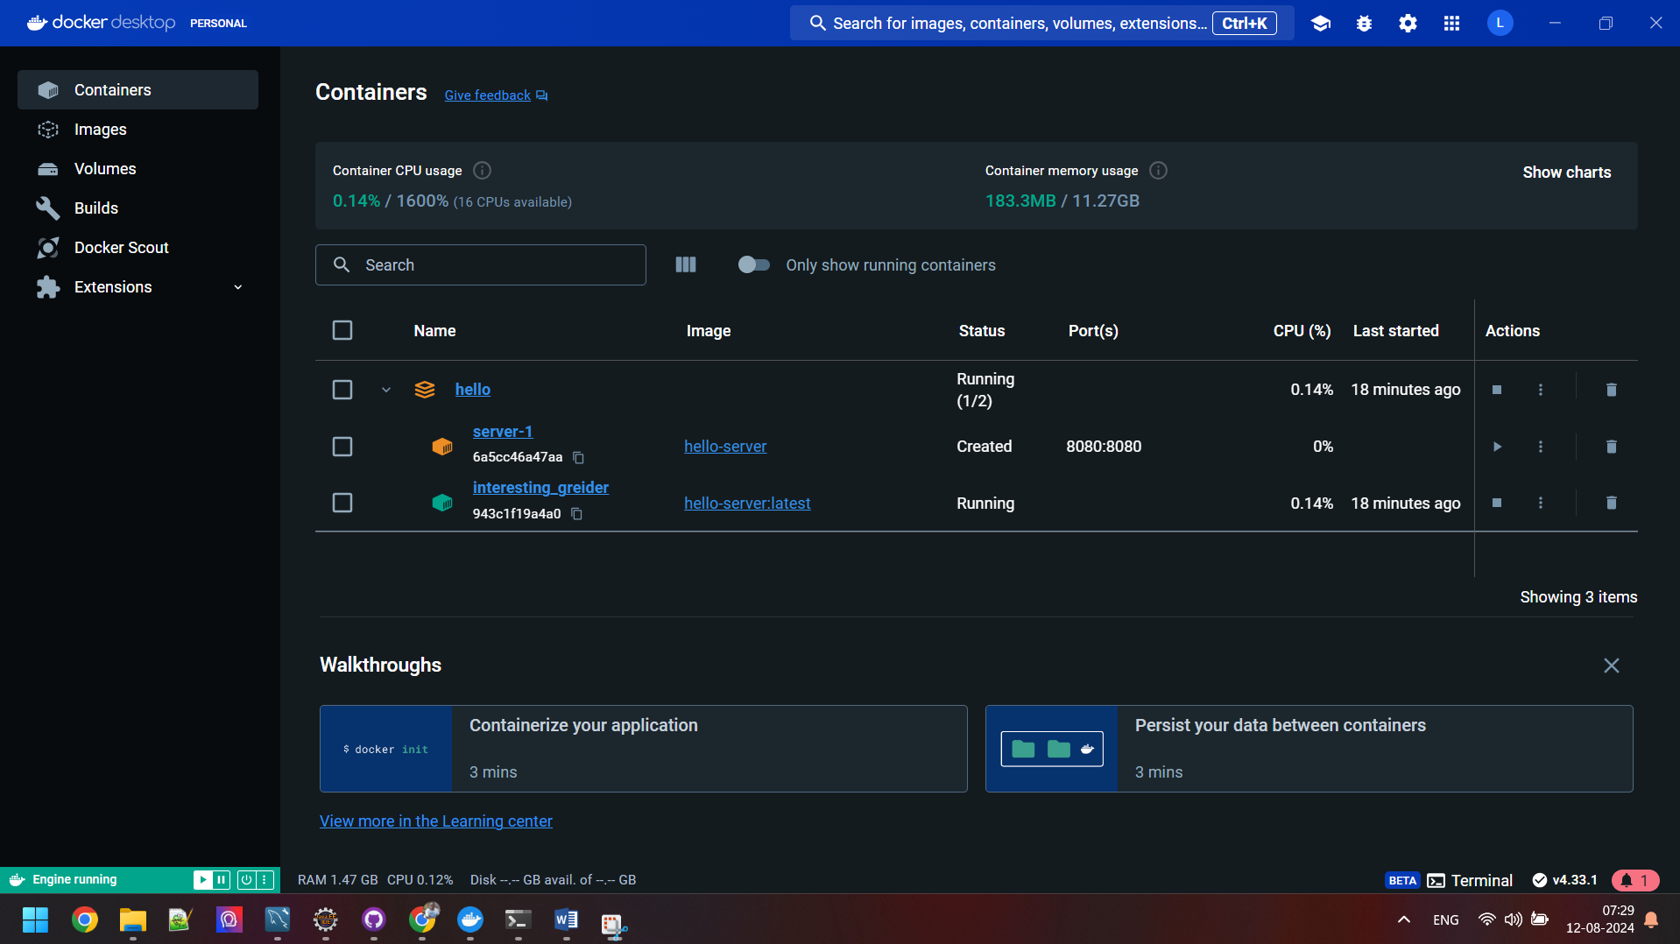

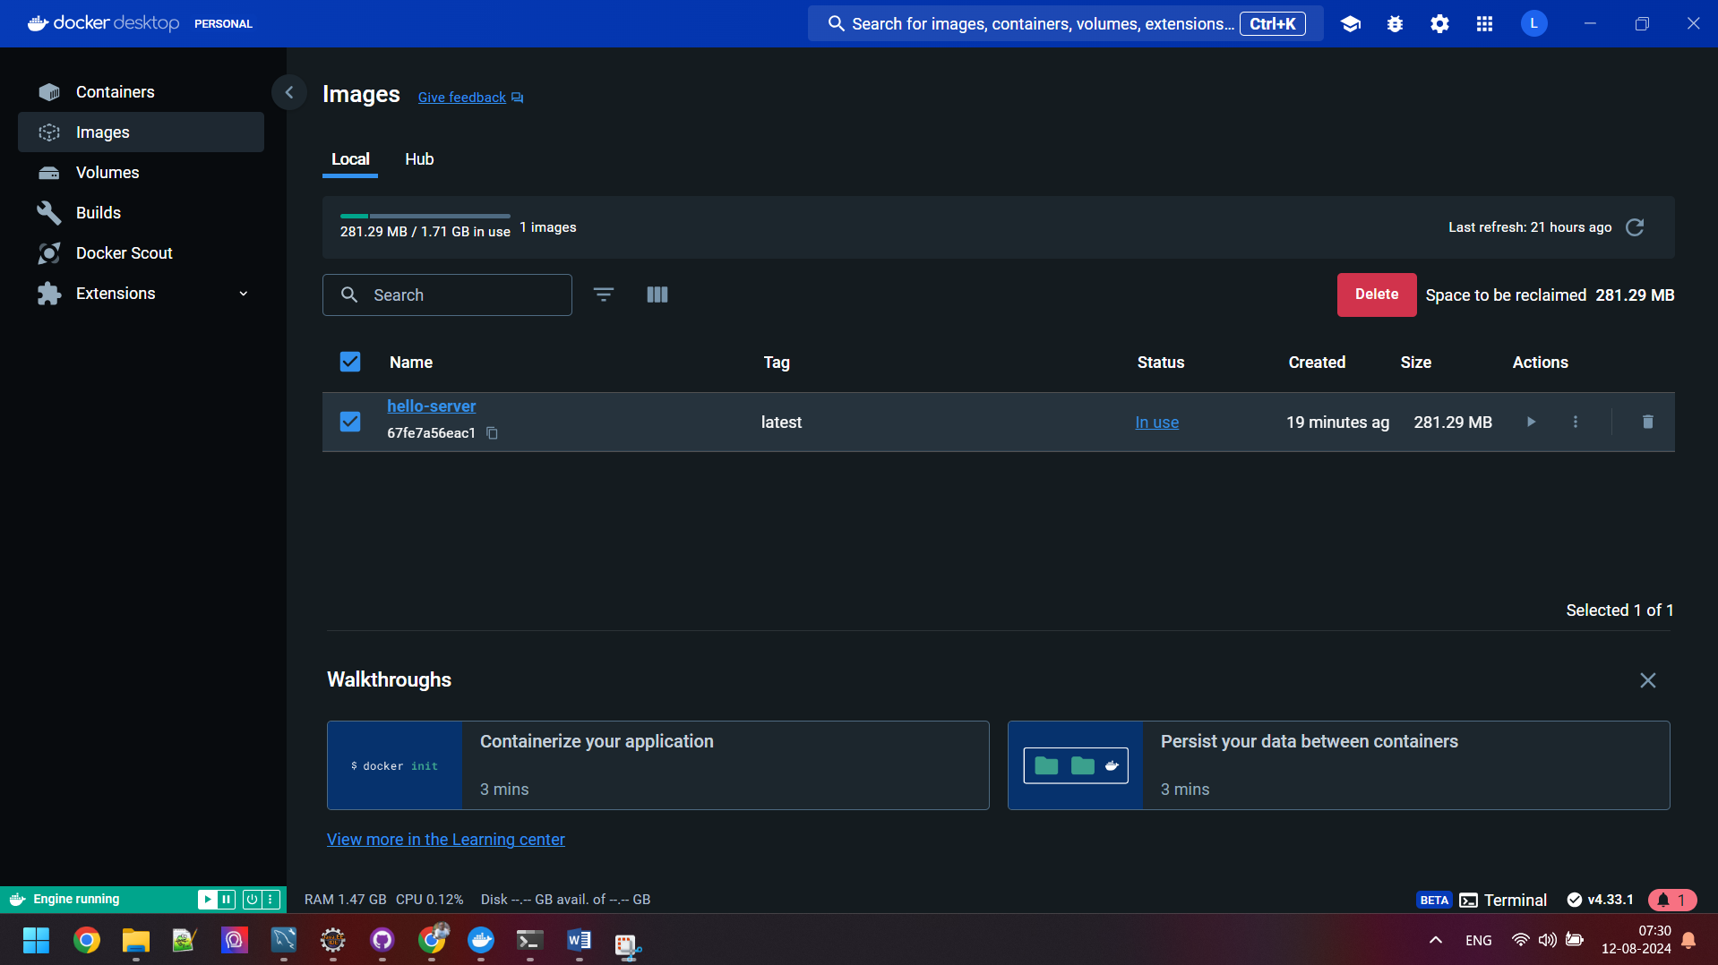

**Test the api:** http://localhost:8080/api/v1/hello

